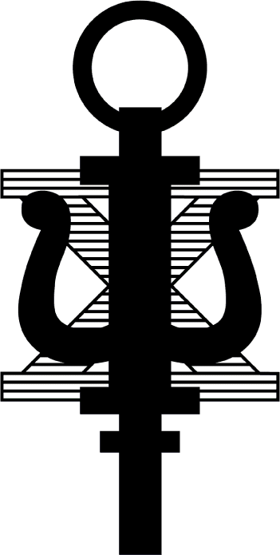
Psi Chi and Psychology Club

Member Meeting

Minutes for November 18th, 2015.

Meeting held in the Rhododendron Room.

Meeting called to order by President Ben Rein at 6:30 pm.

Speaker: Andrew Wheeler

MSIR (Master Studies in Industrial Relations)
- Black Box- IT infrastructure company
- Interned in Human Resources
- 1st job in recruitment and retention
- Got a job a Mylan via Linked IN

- Make a linked in (with a professional picture)
- Job search sites: Indeed, glass door, linked in
- Make those professional connections now!
- This job uses behavioral contingencies that are learned in the field of psychology
- When working in HR you work for the business and must do what is best for them

- You can get a job in HR with your bachelor’s degree
- Careers in HR
  - Talent Acquisition
  - Talent Management
  - Total Rewards – Salary, Benefits, 401K, etc.
  - Employee Relations
  - Human Resources Information Systems – technology

- Look at the short-term vs. the long-term incentives!
- Don’t just take a job for the money
- At the same time, make sure your stable
- Look at the total package: money, benefits, days off, enjoyment of the job
- Show up ready to do the dirty work!
- Don’t sweat the GPA, just do your best
- …BUT get involved in campus, job, and club activates

Secondary Speaker: Helen Nditsi

Program Cordinator for McNair Scholars Program
- 1st generation college students or under-represented students
- Focus on those who want to go to graduate school
- Office of Undergraduate Research
  - Includes information on how to get started
- Talk to Faculty about 495 courses as well and get course credit for your research
- Start out 6 weeks over the summer
- Travel to conferences (all paid!)
- They cover GRE prep courses to help improve your scores
- They also offer CV and personal statement help

- Psi Chi applications due January 31st
- Relay for Life
  - April 22nd, 2016
  - $10 to sign up
- Last Grief Center Dinner tomorrow Nov. 19th
  - Leave LSB around 4:30
- Analyze This
  - January 13th @ 6:00pm
  - Margeaux Gray (Neuroscience)
- Pool Tournament
  - January 31st @ 4:00 pm
  - At Side Pocket at the Lair
- Mock Interviews
  - 6:00-7:00 pm
  - 1111 LSB
  - 1st half interviews
  - 2nd half Q&A
  - Professional attire is encouraged but not required
- Research at the Capitol

- T-Shirt money due today!!!
  - Should be in before Christmas Break

ALL MEETINGS WILL NOW BE IN THE RHODODENDRON ROOM!

Next Meeting is Wednesday January 20th, 2016.

